**Bookmark Website Builder-**

Bookmark.com is a website creation tool for non-technical people. Our simple, drag-and-drop technology combined with AIDA (artificial intelligence design assistant) makes creating a professional website fast and easy.

* **Website Building Platform:** Bookmark.com provides tools and features to help individuals and businesses create their own websites.
* **Features and Templates:** The platform typically offers a range of templates and design features that users can customize to build their websites. This often includes drag-and-drop functionality for easy design.
* **E-commerce Capabilities:** Some website builders, including Bookmark.com, may offer e-commerce functionality, allowing users to set up online stores and sell products or services.
* **Domain and Hosting:** Users might have the option to purchase a domain name through the platform, and hosting may be included as part of the service.
* **SEO and Analytics:** Website builders often include tools for search engine optimization (SEO) to help users optimize their websites for search engines. Additionally, they may provide analytics features to track website performance.
* **Mobile Responsiveness:** Websites created on the platform are usually designed to be mobile-friendly, ensuring a good user experience on various devices.
* **Customer Support:** Bookmark.com likely provides customer support services to assist users with any issues or questions they may have while building and maintaining their websites.

Features –

1. Ai Suggestions - Monitoring visitor interactions on your website, your Artificial Intelligence Design Assistant (AiDA) sends you website optimization suggestions. Implementable with a single click, these suggestions are designed to improve visitor experience and boost their engagement with your website.

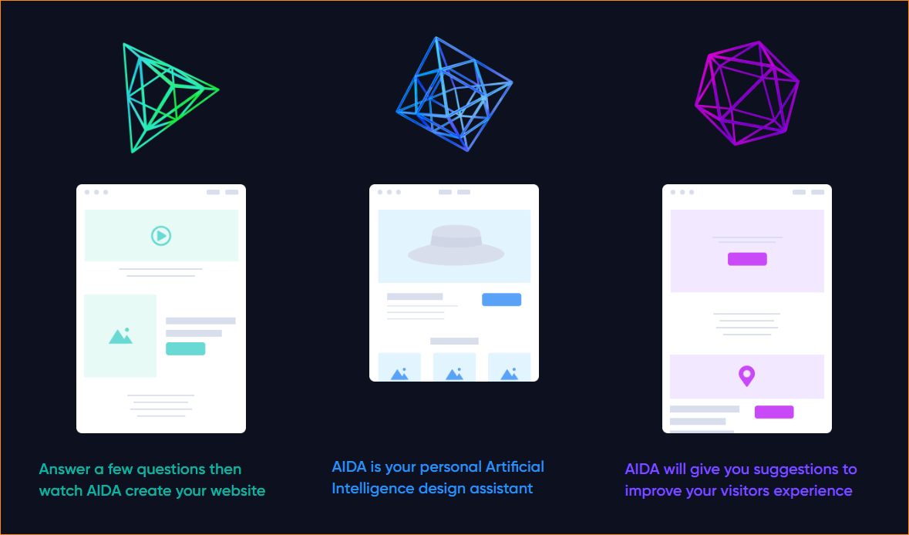

1. Translations

Automatically translate your website to over 100 different languages using Bookmark’s powerful AI. Create up to 3 translated versions of your website with a seamless language selector to attract more customers. Each translation can be edited and customized independently..

1. Drag-and-Drop Interface: Website builders often provide a user-friendly interface where users can add, arrange, and customize elements on their pages using a simple drag-and-drop method.

 

1. Pre-designed Templates: Users can choose from a selection of pre-designed templates, which can serve as a starting point for their website. These templates are often customizable to match the user's preferences.

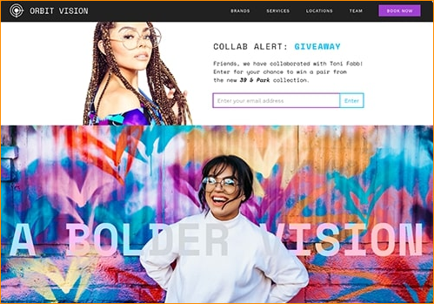

1. No Coding Required: Website builders aim to eliminate the need for users to write or understand code. Instead, users can focus on visual design and content creation without delving into programming languages.
2. Built-in Features: Website builders typically offer built-in features such as image galleries, contact forms, e-commerce capabilities, and more, reducing the reliance on external plugins or coding.
3. Responsive Design: Websites created with these platforms are often designed to be responsive, meaning they adapt to different screen sizes, including mobile devices.
4. Hosting Services: Many website builders include hosting services as part of their packages, simplifying the process of getting a website online.